

User Guide

November 2019



Real Life

Life Changing

Changing Healthcare



Real Life

Life Changing

Changing Healthcare

User Guide

December 2019



Copyright

NAVVIS Unified Ecosystem Experience (UEE) user guide release 1.00.

Copyright © 2019 NAVVIS & Company, LLC. All rights reserved.

Trademarks

The other product names mentioned may be trademarks of their respective owners.

Disclaimer

Sample names and persons used in this document are purely fictitious and do not refer to real names or persons.

This user guide has been created with utmost care; nevertheless, it is not guaranteed that this document is error-free.

No part of this document should be reproduced or transmitted in any form or by any means, electronic or mechanical, for any purpose, without the express written approval of Navvis & Company.

Table of Contents

1 Preface 4

1.1 About Navvis Coreo UEE 4

1.2 About Navvis & Company 4

1.3 Purpose of this Document 4

1.4 Intended Audience 5

1.5 Organization of the Document 5

1.6 Document Conventions 5

Unified Ecosystem Experience (UEE)—User Function 7

1 Coreo UEE Overview 8

2 User Onboarding 9

2.1 Log into UEE—First Time User 10

2.2 About Locked Navvis-Okta SSO Account 15

2.3 Reset a Forgotten or Expired Password 16

3 UEE Panel View—Screen Layout and Navigation 17

3.1 Toolbar Elements 18

3.2 Panel Elements 20

4 Display Settings for UEE Panel View 20

4.1 Display Settings Window—Layout and Navigation 21

5 Configuring a Single Panel Mode 27

5.1 Create a Single Panel View 27

5.2 Pin an Application to the Toolbar 32

6 Creating Presets for Multi-Panel Mode 35

6.1 Configure a 2-Panel View 35

6.2 Save a 2-Panel Configuration as a Preset 37

6.3 Pin a 2-Panel Preset to the Toolbar 40

6.4 Configure a 3-Panel View 42

6.5 Save a 3-Panel Configuration as a Preset 44

6.6 Pin a 3-Panel Preset to the Toolbar 47

6.7 Screens for Optimal Display of Pinned Applications and Presets 49

6.8 Editing an Existing Preset 49

6.9 Switch between Single Panel Mode and Multi-Panel Mode 51

7 Viewing Synchronized Patient Records 55

7.1 Synchronize Patient Records Across Applications in Panel View 55

8 Glossary 56

9 Index 56

# Preface

Welcome to the release of the NAVVIS Coreo UEE (Unified Ecosystem Experience) user guide.

## About Navvis Coreo UEE

The UEE application supports the display of other Coreo ecosystem applications such as Coreo View, Coreo Home, and Coreo Analytics in a single-panel view for standard screen monitors and widescreen monitors, and in multi-panel view for widescreen monitors.

The user can view all those applications available through the Navvis-Okta single sign-on (SSO) account on the UEE screen though one panel, two panels or three panels.

The Coreo ecosystem includes the following applications as illustrated below:

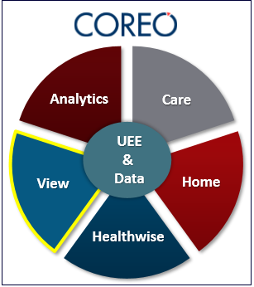

UEE allows its users to configure an application and to view it in a single panel or configure multiple applications to view them in multiple panels on their device screens, with each application assigned to a panel.

## About Navvis & Company

Navvis & Company provides counsel to health systems, hospitals, and physician groups on the development of innovative, market-linked strategies to build future-ready health systems, cultivate tomorrow’s leaders, and strengthen strategic performance.

## Purpose of this Document

This guide is the principal source of information about Navvis Unified Ecosystem Experience. It contains overviews, processes, and procedures to use the Unified Ecosystem Experience application effectively.

## Intended Audience

1. The regular users of the Unified Ecosystem Experience application who include the following personnel:

* Clinical staff and hospital administrators
* Employees, consultants, contractors, or agents of the clinicians or patients who have been invited by the clinician or patient to access and use the service to participate in the care of the patient
* Any other person or entity involved in the care of the patient, including patient's care providers, patient's insurer or payer, or a social worker, or government agencies

1. Unified Ecosystem Experience administrator users who are assigned the task of managing the regular users of the Unified Ecosystem Experience application

## Organization of the Document

This document contains the following modules:

* Module 1, “User Onboarding”
* Module 2, “UEE panel view—Screen layout and Navigation”
* Module 3, “Display settings for UEE panel view”
* Module 4, “Creating presets for single panel format”
* Module 5, “Creating presets for multi-panel format”
* Module 6, “Editing the toolbar”
* Module 7, “Panel formats and screen resolutions”
* Module 8, “Synchronizing patient records”

## Document Conventions

This document uses the following conventions:

| Convention | Item |
| --- | --- |
| **boldface** font style | **Menu** items, **Tab** names, **Text** **box** names, **List** **box** names, **Button** names and **Navigation** paths |
| Text in blue | Hyperlinks |
| *Italics font style* | *Examples* |
|  | Note: Notes contain helpful suggestions. A note informs the reader about any deviation in the sequence of instructions or helps the reader save time in understanding why something is not working. |
|  | Tip: The information helps the user solve a problem faster or to perform an action differently. |
|  | Caution alerts the reader to avoid doing something that could result in loss of data or any other damage. |

Unified Ecosystem Experience (UEE)—User Function

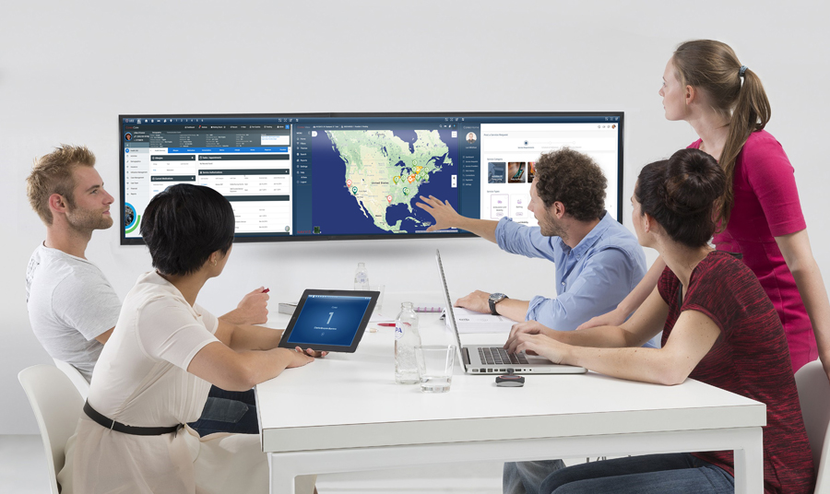

# Coreo UEE Overview

Coreo UEE provides the convenience of viewing all the applications available through the Navvis-Okta single sign-on (SSO) account that the users have access to on standard screen monitors and widescreen monitors either in a single-panel mode or in a multi-panel mode.

The following illustration gives an overview of how the UEE application works:

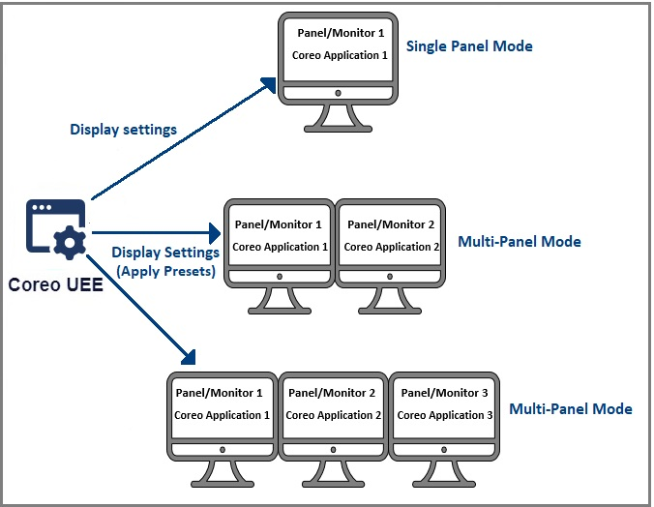

1. Coreo UEE Overview

|  |  |
| --- | --- |
|  | As a pre-requisite to use the Coreo UEE application, you must have the access rights to the Coreo View application given by your Okta administrator. |

Use the display settings feature in UEE to do the following:

* Configure the device screen to view the applications either in a single-panel mode or in a multi-panel mode.
* Change the toolbar preference on the UEE screen to pin the applications and presets so that the user can apply the required configurations to the screen easily.

# User Onboarding

A first-time user of Unified Ecosystem Experience (UEE) receives an automated email verification link from the Okta system administrator to activate the Okta account.

The Okta single sign-on(SSO) service provides a single secure home page to log into the UEE application and other applications that are part of the Coreo ecosystem.

As a user, you can access only those Coreo applications for which you have permission for and based on the role assigned to you by your system administrator.

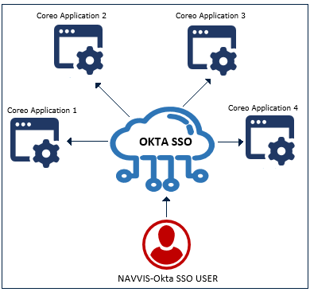

1. Navvis-Okta SSO for Coreo applications

## Log into UEE—First Time User

Follow these steps to activate the Navvis-Okta SSO account to access the Unified Ecosystem Experience application:

1. Open the email link sent to your email inbox by the Okta administrator.



1. Email Notification
2. Select the ActivateAccLinkGreenBox.png link. The **Create your Navvis account** screen opens.

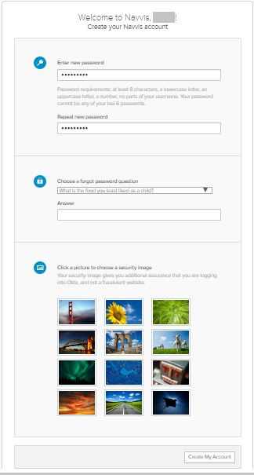

1. Create Your Navvis Account Screen
2. Enter the new password in the **Enter new password** box. The password must be at least 8 characters long and a maximum of 25 characters.

The password must be a combination of these following characters:

| Description | Characters |
| --- | --- |
| Upper case characters | A – Z |
| Lower case characters | a – z |
| Digits | 0 – 9 |
| Special characters | ~ ! @ # $ % ^ & * _ - + = ` | \ () {} [] : ; " ' < > , . ? / |

1. System Accepted Password Characters
2. Reenter the password in the **Repeat new password** box.
3. The user must add a security question to reset a new password in the scenario where the user may forget the password during the next use.
4. Under **Choose a forgot password** question on the **Create your Navvis account** screen, select the arrow to view the questions.



1. Choose A Forgot Password Question
2. Choose a security question from the list.
3. In the **Answer** box, enter the answer. You must remember this answer because it is used at a later date to reset a forgotten or expired password.
4. Choose a picture as a security image on the **Create your Navvis account** screen and then select **Create My Account**.

|  |  |
| --- | --- |
|  | The security image displays in the Coreo Sign In screen on entering the user name. |

1. The **Coreo** landing screen opens.

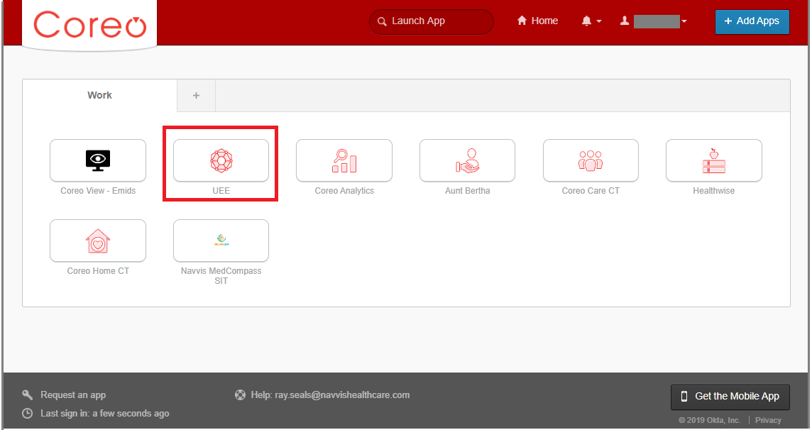

1. Coreo Landing Screen
2. Select the **UEE** button on the landing screen. The Coreo applications that you see on the Coreo landing screen depends upon the user role and permissions assigned to you by your NAVVIS system administrator.
3. The **Coreo Sign In** screen opens.

|  |  |
| --- | --- |
|  | Once the user accepts EULA and the Navvis-Okta SSO account is activated, the new user becomes an existing user.  As an existing user, go to [navvis.oktapreview.com](https://navvis.oktapreview.com/) to open the Coreo Sign In screen. |

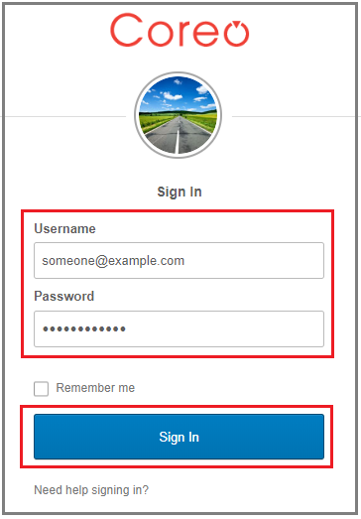

1. Coreo Sign In Screen
2. Enter the user ID in the **Username** box.
3. Enter the password in the **Password** box. The password must be at least 8 characters long and a maximum of 25 characters.
4. Select **Sign In**.
5. The EULA screen displays for a first-time user of UEE. A first-time user of UEE is required to accept the EULA (End User License and Business Associate Agreement) before accessing the UEE application.

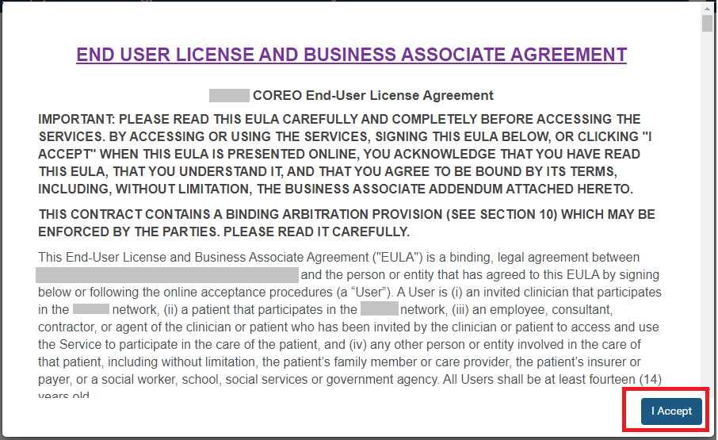

1. EULA PAGE
2. Read the terms and conditions and select the **I Accept** button. Your NAVVIS account is activated successfully, and the UEE home page opens.

## About Locked Navvis-Okta SSO Account

The Navvis-Okta SSO account locks for the following reasons:

* The user exceeds five failed login attempts within 24 hours. The login attempts fail when the user enters an incorrect password.

The locked account resets after 24 hours, and the user can log in to the account after 24 hours without contacting the Okta system administrator.

|  |  |
| --- | --- |
|  | To unlock the NAVVIS account immediately after the five failed login attempts, contact the Okta system administrator. |

* The Okta system administrator can lock the NAVVIS-Okta SSO account as per the company lock account policy.

## Reset a Forgotten or Expired Password

The Okta single sign-on password policy specifies that the password expires after 60 days, and the user must reset the password periodically.

Also, if the user forgets the password, Navvis-Okta gives the option to reset the password.

Follow these steps to reset the password:

1. Go to [navvis.oktapreview.com](https://navvis.oktapreview.com/) to open the **Coreo Sign In** screen.

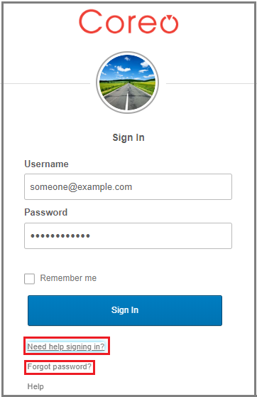

1. Coreo Sign In Screen—Need help signing In?
2. Select the **Need help signing in?** drop-down list.
3. Select the **Forgot Password?** option to open the **Reset Password** screen.

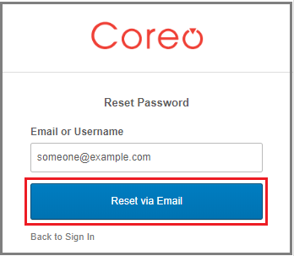

1. Reset Password Screen
2. Enter the email or the user name in the **Email or Username** box.
3. Select **Reset via Email**. You will receive an email with a verification link from the Okta administrator. You can reset the password using the verification link sent to your email address.
4. Reset the password with the following considerations:

* The new password cannot be among the previous six passwords.
* The password expires after 60 days, and the user must reset the password periodically.
* The user is locked out of the application after five failed login attempts. The login attempts fail when the user enters an incorrect password. Contact the Okta administrator to reset the password.

On the successful resetting of the password, you can use the new password to log into your Navvis-Okta SSO account.

# UEE Panel View—Screen Layout and Navigation

The screen layouts in the UEE application are similar in appearance. However, a few user interface elements differ depending upon the following reasons:

* The number (one, two or three) of panels that are displayed on the screen
* The type of user login — a first time user of UEE or an existing user
* The user’s role and permissions

The following figure is the default screen view of the UEE application when the user logs into the application as a first time user.

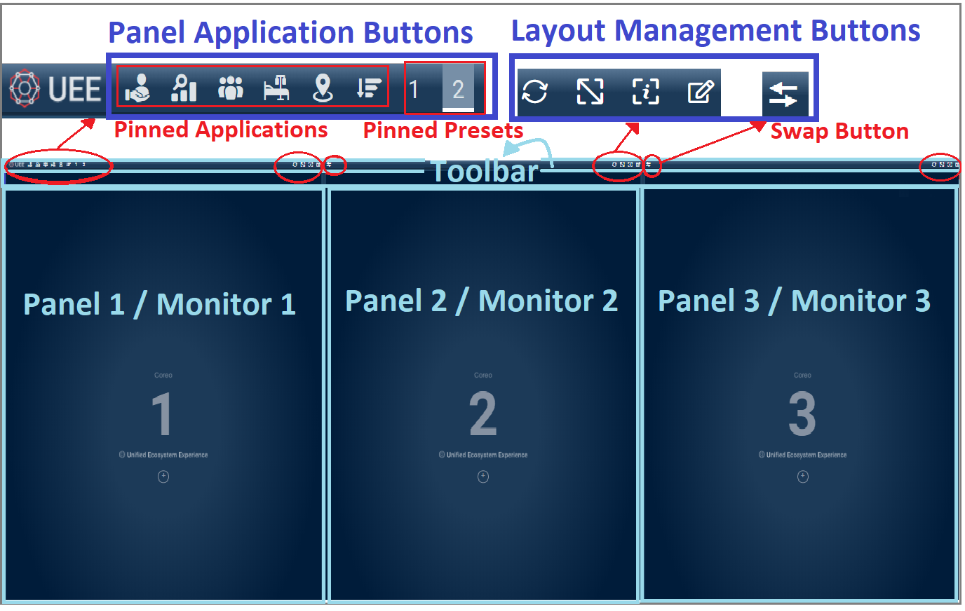

1. UEE Screen on First time Login—3-Panel View

The UEE home page layout includes the following areas:

* Toolbar: Includes buttons to apply the presets to the panels, to access the display settings for the panel, and to control the magnification settings of the panel screen.
* Panel/Monitor: Each Coreo application can be assigned to a panel and can have a maximum of 3-panel on the device screen.

Toolbar Elements

The toolbar runs across all the three panels on the UEE screen. The **Refresh** button, the **Maximize Display** button, the **Help** button, and the **Display** **Settings** button are available for each panel. These buttons are located in the upper-right corner of the panel on the toolbar.

The **Swap** button is located in the upper-left corner of the second panel and third panel on the toolbar.

Refer to the following table to view details about the elements on the toolbar.

| Icon | Element name | Description |
| --- | --- | --- |
|  | **UEE** Logo | The UEE logo |
| **Panel layout management buttons** | | |
|  | **Refresh** button | Use this to refresh the Coreo application of that panel. |
|  | **Maximize Display** toggle button | Use this button to enlarge the panel layout view to fit the entire screen of the device. Select the same button or select **Esc** on the keyboardto exit the full screen. |
|  | **UEE Help** button | Use this button to open the UEE user help document. |
|  | **Display Settings** button | Use this button to open the **Display Settings** pop-up window. In the pop-up window, you can create, modify, or delete presets. You can also pin a Coreo application or a preset to the toolbar using this window. |
|  | **Swap** button | Use this to interchange the applications between two panels. |
| **Panel Application Buttons** | | |
|  |  |  |
|  |  |  |
|  |  |  |
|  |  |  |
|  |  |  |
|  |  |  |
|  |  |  |

1. Toolbar—UI Element Names

## Panel Elements

Refer to the following table to view details about the elements in the panel.

| Icon and Element Name | Description |
| --- | --- |
| Panel 1 | The first panel.  The UEE screen can display a maximum of three panels on the device screen. The first panel is the Left (**L**) panel. |
| Panel 2 | The second panel.  The second panel is the Central (**C**) panel. |
| Panel 3 | The third panel.  The third panel is the Right (**R**) panel. |
| **Display Settings** button | Use this button to open the **Display Settings** pop-up window. You can click anywhere in the panel area to open the **Display** **Settings** window. |
| UEE logo | The UEE logo |

1. Panel—UI Elements Names

# Display Settings for UEE Panel View

Use the display settings feature in UEE to configure the following modes on your device screen:

* Single panel mode: You can configure a Coreo application to view it in a single panel layout. The single panel mode is available on standard screen monitors and widescreen monitors.
* 2-panel mode (Multi-panel mode): You can configure the Coreo applications to view them in a 2-panel layout, with each application assigned to a panel. The 2-panel mode is compatible with widescreen monitors only. You can save the configurations of a 2-panel mode as presets.
* 3-panel mode (Multi-panel mode): You can configure the Coreo applications to view them in a 3-panel layout, with each application assigned to a panel. The 3-panel mode is compatible with widescreen monitors only. You can save the configurations of a 3-panel mode as presets.

UEE also allows its users to pin the Coreo applications and presets on the toolbar of the UEE screen to access and apply the screen configurations easily.

## Display Settings Window—Layout and Navigation

UEE provides the flexibility to configure different Coreo applications to view in different panels on the device screen.

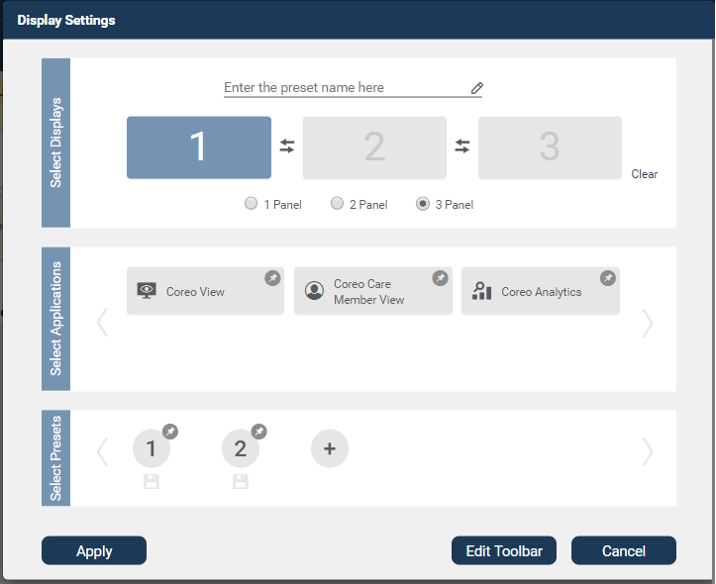

1. Display Settings pop-up window

Refer to the following table to view details about the elements in the **Display** **Settings** window.

| Icon and Element name | Description |
| --- | --- |
| **Select Displays** group | In this group, do the following:   * Select the number of panels to display on the device screen. * Swap the applications between the panel slots when configuring the applications for a 2-panel view and a 3-panel view. * Delete the applications assigned to the panel slots using the **Clear** button. |
| 1 Panel slot | Use this slot to assign a Coreo application to the first panel on your display screen.  In a single panel view, you can display the Coreo application either in the left panel or in the central panel or the right panel. |
| First-panel slot–Empty and Highlighted | An empty panel slot. When the user selects a panel slot, it highlights a blue color. |
| First-panel slot–Assigned | A panel slot with an application assigned to it |
| **L C R** position buttons | Use these buttons to position the application view either in the (**L**) left panel or in the (**C**) central panel or the (**R**) right panel on the device screen.  These buttons are available only when you select the **1 Panel** button. |
| **2 Panel** slot | Use this slot to assign a Coreo application to the second panel on your display screen.  In a 2-panel mode, you can assign an application each to both panel 1 and panel 2. |
| Second-panel slot–Empty and Highlighted | A selected panel slot to which an application can be assigned |
| Panel slot–Non-Highlighted | A cleared panel slot. |
| **3 Panel** slot | Use this slot to assign an application to the third panel on your display screen.  In a 3-panel mode, you can assign an application each to panel 1, panel 2 and panel 3. |
| Third-panel slot–Empty and Highlighted | A selected panel slot to which an application can be assigned |
| Swap button | Use this button to swap the applications between the panel slots when configuring the applications for a 2-panel view and a 3-panel view. |
| **Clear** button | Use this button to delete the applications assigned to the panel slots. |
| Panel button group | In this button group, select the number of panels to display on the device screen. |
| **1 Panel** button | Select this button to display the application in a single panel on the device screen. |
| **2 Panel** button | Select this button to display the applications in a 2-panel layout on the device screen, with each application configured to a panel. |
| **3 Panel** button | Select this button to display the Coreo applications in a 3-panel layout on the device screen, with each application configured to a panel. |
| **3 Panel** button–Selected | A selected radio button |
| Preset name box | Enter the name of the preset in this box to save the preset and apply it to the device screen.  You can save only 2-panel and 3-panel configurations as presets. |
| **Select Applications** group | In this group, do the following:   * Select the application to assign to the panel slot. * Pin the applications to the toolbar of the UEE screen using the **Edit Toolbar** button in the lower-right corner of the **Display Settings** window. |
| Application slots | The applications to assign to the **1 Panel** slot to configure a single panel mode.  **Coreo View** – **Prioritized View**, **Coreo** **View – Bed View**, and **Coreo View – Geomap View** applications are available for 1-panel slot only. |
| Application slot–blue | A selected application—an application that is assigned to a panel slot |
| Pin icon–blue | A pinned application.  An application that is pinned to the toolbar of the UEE panel screen on the monitor device |
| Application slot–grey | An application that is not assigned to a panel slot |
| Pin icon–grey | An unpinned application.  An application that is not pinned to the toolbar of the UEE panel screen on the monitor device |
| Application slots | The applications to assign to the **2 Panel** slots and **3 Panel** slots. Configure the 2-panel mode and 3-panel mode, respectively. |
| Left Chevron icon | Use this to navigate to the left and access the applications that are not within the default view of the **Display Settings** window. |
| Right Chevron icon | Use this to navigate to the right and access the applications that are not within the default view of the **Display Settings** window. |
| **Select Presets** group | In this group, do the following   * Save the configurations as presets to apply to the UEE panel screen for a 2-panel mode and a 3-panel mode. * Pin the applications to the toolbar of the UEE screen using the **Edit Toolbar** button in the lower-right corner of the **Display Settings** window. |
| Preset icon | A saved preset. Save a configuration as a preset for a 2-panel or a 3-panel view only. |
| Pin icon–grey | A non-pinned preset.  A preset that is not pinned to the toolbar of the UEE panel screen |
| Pin icon–blue | A pinned preset.  A preset that is pinned to the toolbar of the UEE panel screen on the monitor device |
| Preset icon–blue | A highlighted preset.  A preset icon highlights when you select an existing configuration (the number of panels and the applications assigned to them) in the **Display** **Settings** window |
| Save button | Use this to save the preset. |
| Add Preset button | Use this button to create a new preset. You can save a configuration as a preset for a 2-panel or a 3-panel view only. |
| **Apply** button | Use this button to apply a single panel configuration or presets to the UEE panel screen. |
| **Edit Toolbar** button | Use this button to edit the toolbar of the UEE panel screen. You can pin the applications and presets to the toolbar. |
| **Cancel** button | Use this button to close the **Display** **Settings** window. |

1. Display Settings Window—UI Element Names

# Configuring a Single Panel Mode

Single panel mode in UEE gives you the provision to view an application in a single panel frame. You can configure the view using the display settings feature to position the application view either on the left side of the device screen, or right side or in the center.

You, as a user, have the flexibility of customizing the toolbar by pinning the applications so that you can apply the application quickly to the device screen and switch between them easily.

## Create a Single Panel View

Follow these steps to configure a single panel view on the UEE screen of your device:

1. Click the UEE application on the Coreo Landing screen to open the UEE screen.

|  |  |
| --- | --- |
|  | For a first time user of the UEE application, a blank 3-panel layout displays as the default screen view. If you are an existing user, the panel view configuration (preset) or the application that you last applied during your previous login session displays on the UEE screen. |

1. Select the **Display** **settings** button on the toolbar or click anywhere in the blank panel frame to open the **Display** **Settings** window.
2. In the **Select** **Displays** group, select the **1 Panel** radio button. A single panel slot displays.

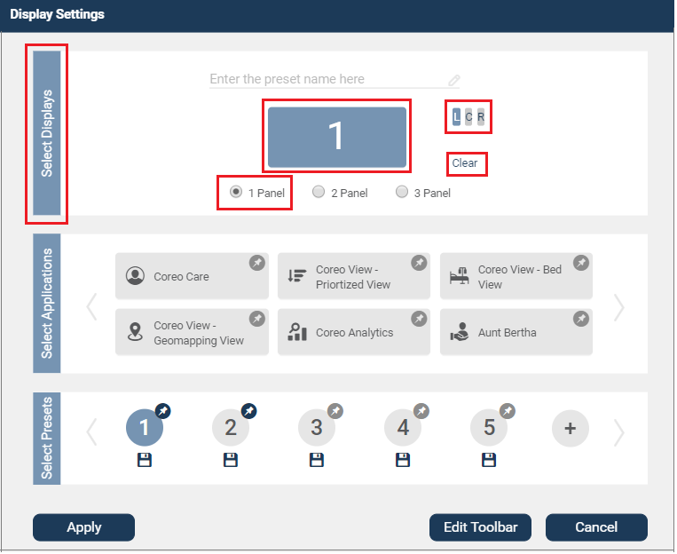

1. Display Settings Window—1 Panel Slot

|  |  |
| --- | --- |
|  | If you switch from the 2 Panel button or 3 Panel button to the 1 Panel button, an existing application that is already assigned to the first panel displays in the Panel 1 slot. You can use the Clear button to clear the Panel 1 slot to reassign another application.  Similarly, if you switch from the 2 Panel button to the 3 Panel button, the existing applications that are already assigned to the first panel and second panel displays in the Panel 1 slot and panel 2 slot, respectively. |

1. In the **Select** **Applications** group, select the application to assign to the single panel slot.

|  |  |
| --- | --- |
|  | In the Select Applications group, you can view only those applications that the Okta administrator has given access to. |

For a single panel slot, the Coreo View application under the **Select Applications** group is available in three views, **Coreo View-Prioritized View**, **Coreo View-Bed View,** and **Coreo View-Geomapping View**.

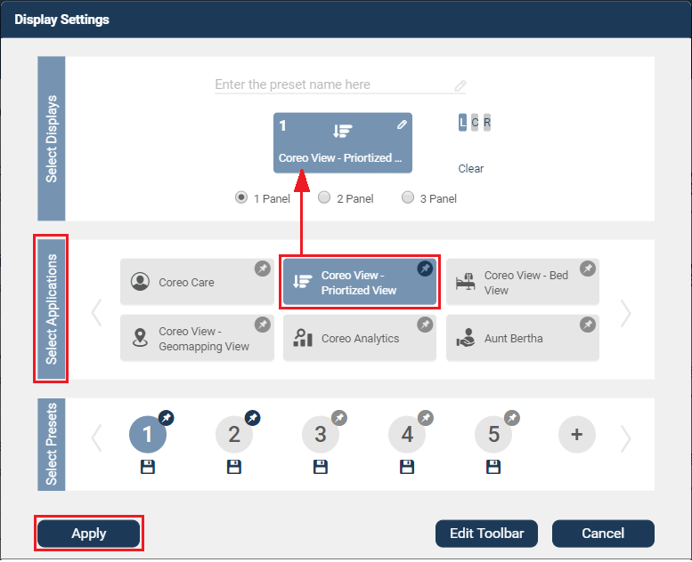

1. Display Settings Window—Assigning an Application
2. Click the **Apply** button to apply the single panel configuration to the UEE screen on your device. The default position of the configured panel is on the left (**L**) side of the device screen.

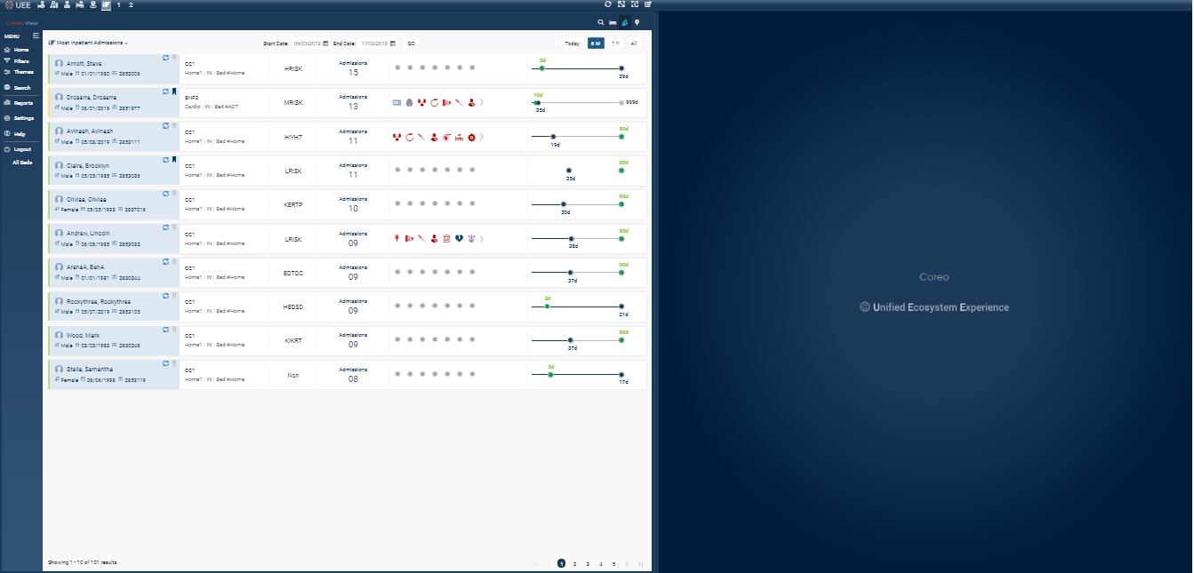

1. Device Screen in Single Panel Mode—Left (L) Position
2. To position the configured panel at the center of the screen, click the **C** button in the **Display** **Settings** window and then click the **Apply** button.

The configured panel displays in the middle of the device screen.

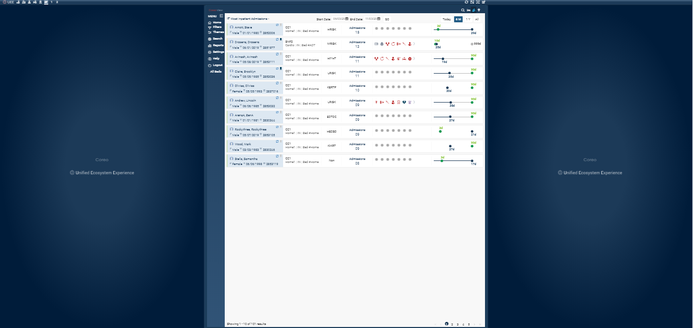

1. Device Screen in Single Panel Mode—Center (C) Position
2. To position the configured panel on the right side of the screen, click the **R** button in the **Display** **Settings** window and then click the **Apply** button. The configured panel displays on the right side of the device screen.

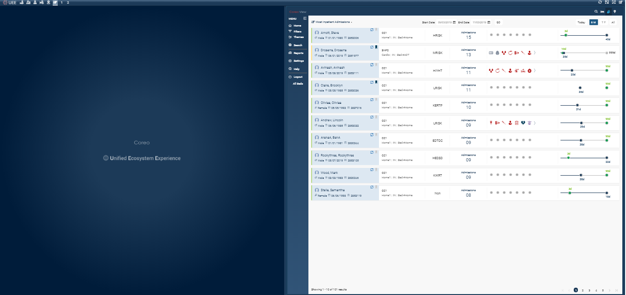

1. Device Screen in Single Panel Mode—Right (R) Position

When you assign the **Coreo View-Bed View** application to the single panel slot in the **Display Settings** window and apply the configuration to the screen, the configured panel with the Bed view application stretches across the entire width of the device screen.

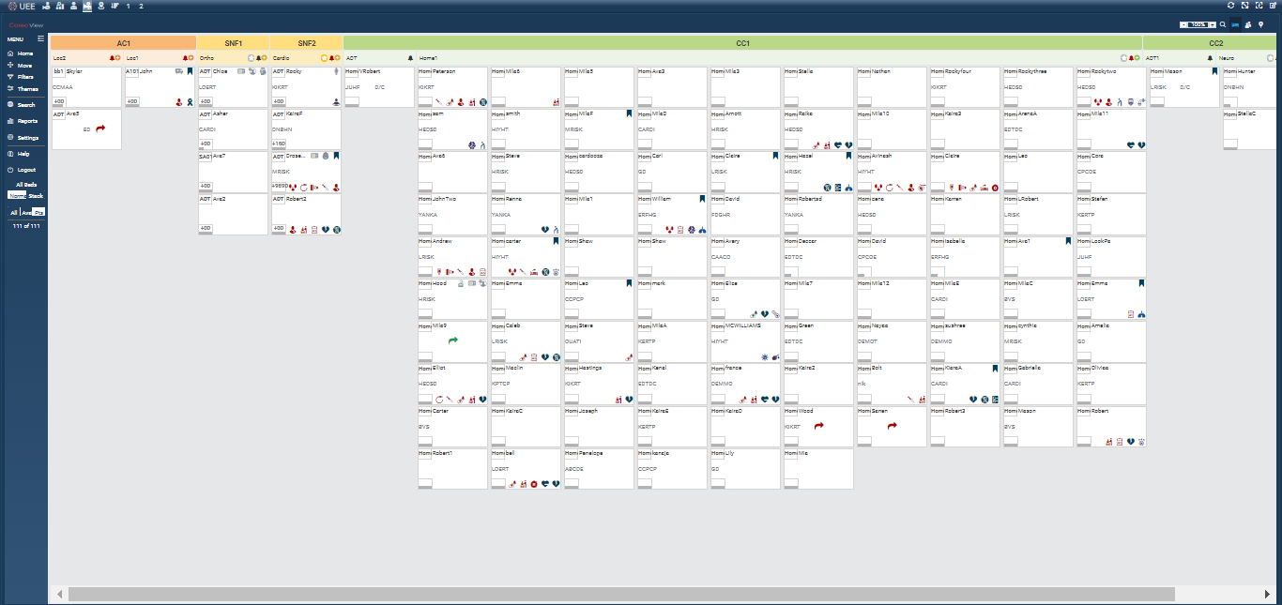

1. Device Screen in Single Panel Mode—Bed View Application

Similarly, when you assign the **Coreo View-Geomap View** application to the single panel slot in the **Display Settings** window and apply the configuration to the screen, the configured panel with the Geomap view application stretches across the entire width of the device screen.

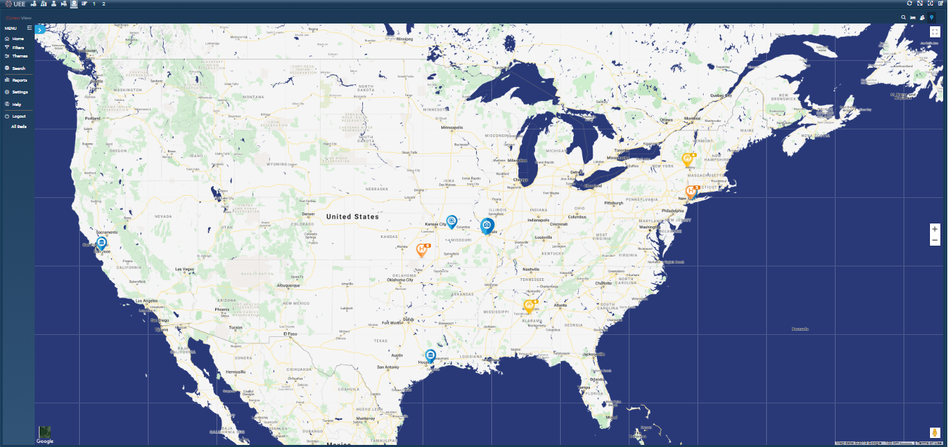

1. Device Screen in Single Panel Mode—GeoMapping View Application

## Pin an Application to the Toolbar

You can customize the toolbar by pinning applications to it. You can switch between applications and apply them to the screen quickly. When you select a pinned application from the toolbar and apply it to the UEE screen, it displays in a single panel mode on the monitor.

Follow these steps to pin an application to the toolbar:

1. Select the **Display** **settings** button or click anywhere in the blank panel frame to open the **Display** **Settings** window.

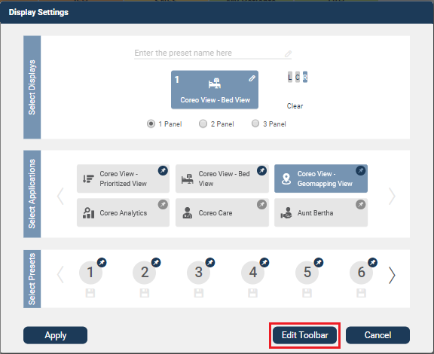

1. Display Settings Window—Edit Toolbar Button
2. Click the **Edit** **toolbar** button.

In the **Select** **Applications** group, each application slot has a pin icon displayed at the upper right corner of the slot-frame. The grey pin indicates that the application is not pinned to the toolbar.

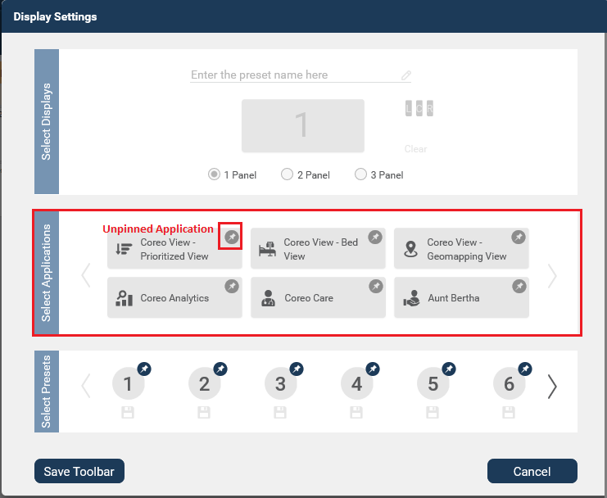

1. Display Settings Window—Edit ToolBar—Unpinned Applications
2. Click the application slot and select the application that you want to pin to the toolbar. On selecting the application, the grey color pin changes to a blue color, indicating that the application is pinned to the toolbar.

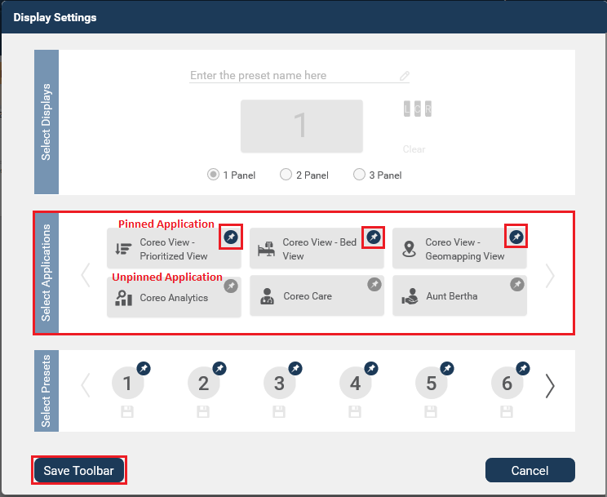

1. Display Settings Window—Edit ToolBar—Pinned Applications
2. Click the **Save Toolbar** button to save the changes that you made to the toolbar. The pinned applications display on the toolbar. When you apply an application to the screen, its icon on the toolbar highlights.

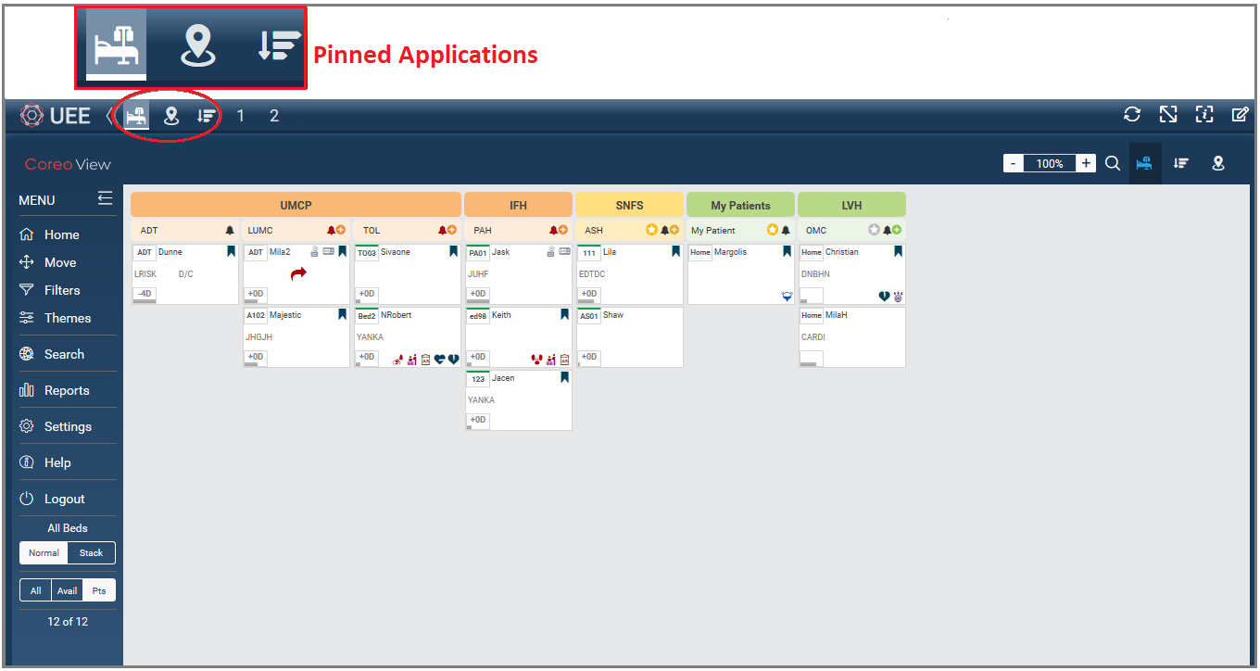

1. UEE Screen—Pinned Applications

This pinned application displays in a single panel mode on the monitor screen.

# Creating Presets for Multi-Panel Mode

UEE gives you the flexibility to view the applications that you have access to through a 2-panel, or a 3-panel display.

You can assign two different applications to two different panels/monitors or three applications to three panels/monitors and save these configurations as presets.

Presets help you to store the most frequently used configurations for later use. You can also pin the presets to the toolbar. Pinning presets to the toolbar helps you to customize the toolbar to store and access the most frequently used presets with ease.

## Configure a 2-Panel View

Follow these steps to configure a 2-panel view in the **Display** **Settings** window and apply it on the UEE screen of your device:

1. Click the UEE application on the **Coreo Landing** screen to open the UEE screen.
2. Select the **Display** **settings** button or click anywhere in the blank panel frame to open the **Display** **Settings** window.

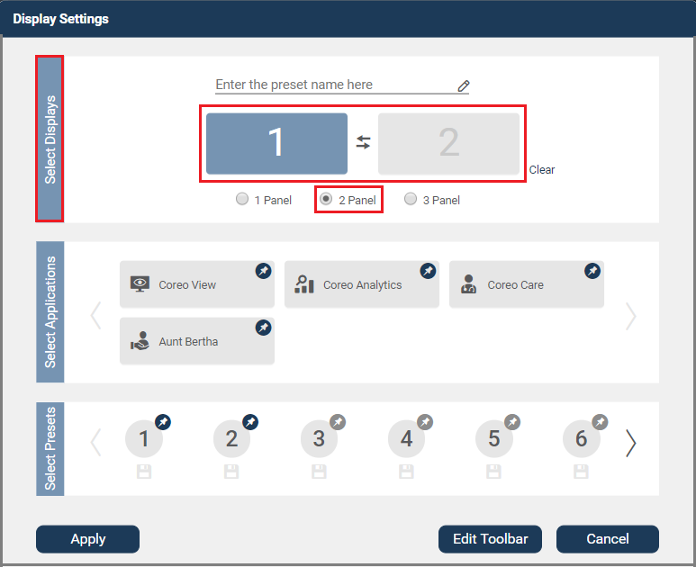

1. Display Settings Window—2 Panel Slot
2. In the **Select** **Displays** group, select the **2 Panel** radio button. A two-panel slot displays.
3. Select the first panel, and in the **Select** **Applications** group, select the application to assign to the selected panel slot.

You can use the **Clear** button to clear the panel slots to reassign the applications if the panel slots have preassigned applications.

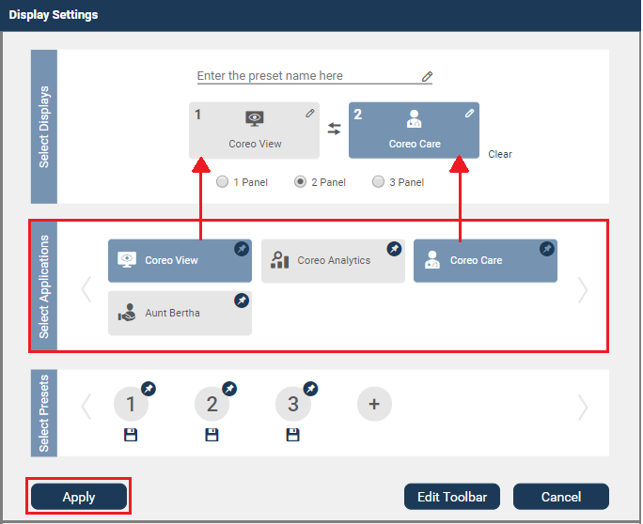

1. Display Settings Window—Assigning Applications to Panel Slots
2. Select the second panel, and in the **Select** **Applications** group, select the application to assign to the selected panel slot.

If you choose to interchange the assigned applications between the panel slots, you can use the swap button .

*For example, if you have assigned the Coreo View application to panel 1 and Coreo Care application to panel 2 and if you click the Swap button, then the Coreo View application that was assigned to panel 1 is now assigned to panel 2 and Coreo Care application to panel 1.*

|  |  |
| --- | --- |
|  | UEE gives you the flexibility to select the panel slots in the order of your choice when assigning the applications; you can either select panel 1 first or panel 2 when assigning the application. |

1. Click the **Apply** button to apply the 2-panel configuration to the UEE screen on your device.

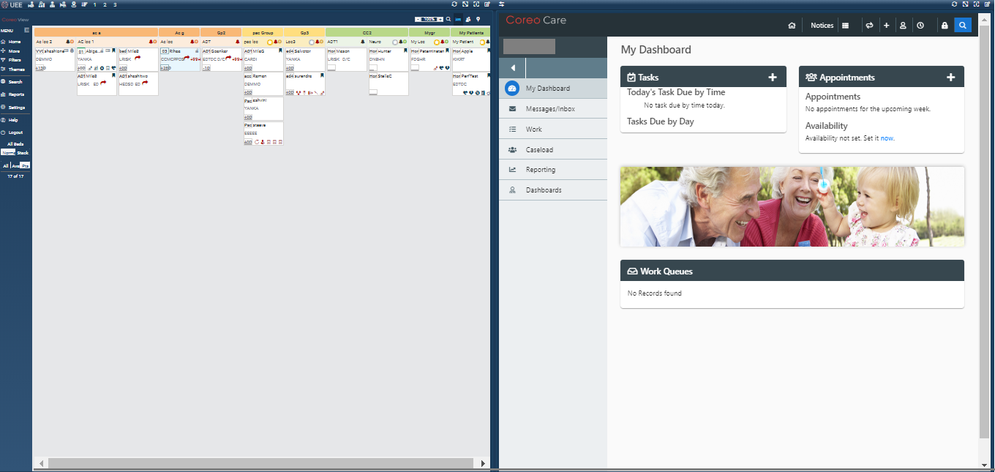

1. Device Screen in 2-Panel Mode

## Save a 2-Panel Configuration as a Preset

UEE gives the provision to save a 2-panel configuration as a preset.

Follow these steps to save a 2-Panel configuration as a preset:

1. Select the **Display** **settings** button or click anywhere in the blank panel frame to open the **Display** **Settings** window.
2. Click the Add Preset button in the **Select Presets** group.

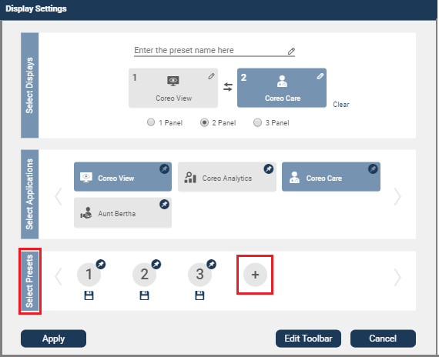

1. Display Settings Window—Add Preset Button

A new preset icon is created with the preset number auto-generated by UEE.

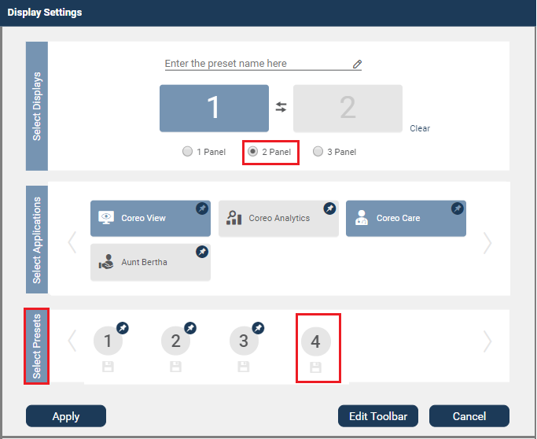

1. Display Settings Window—Newly Added Preset
2. Select the **2 Panel** radio button in the **Select Displays** group.
3. Select the first-panel slot, and in the **Select** **Applications** group, select the application to assign to the selected panel.

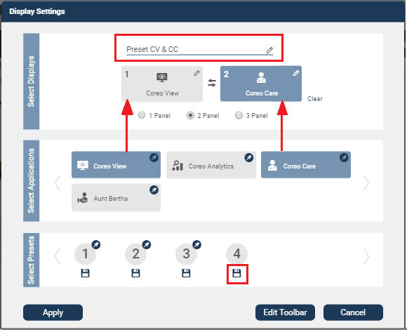

1. Creating a Preset
2. Select the second-panel slot, and in the **Select** **Applications** group, select the application to assign to the selected panel.
3. Enter the preset name in the **Enter the preset name here** box. This preset name displays as a tooltip to the pinned preset on the toolbar. You also can enter the preset name before assigning the applications to the panel slot.
4. Click the Save button below the preset icon in the **Select** **Presets** group to save the 2-panel configuration as a preset.

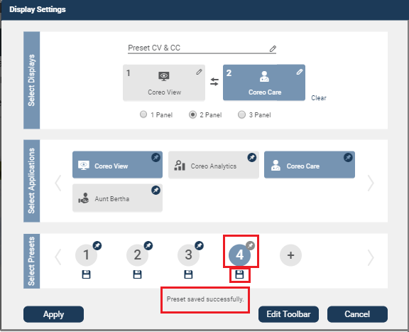

1. Saving a Preset

On saving the preset, a message, “**Preset saved successfully**” displays indicating that the preset is saved successfully. A grey pin icon displays with the saved preset, and you can pin this preset to the toolbar.

1. Click the **Apply** button to apply the saved preset to the device screen immediately or click the **Cancel** button to exit the **Display** **Settings** window without applying the saved preset, but to use it when required.

## Pin a 2-Panel Preset to the Toolbar

You can customize the toolbar by pinning the presets to it. Pinning the presets helps you to switch between presets and apply the required preset to the screen quickly.

Follow these steps to pin a 2-Panel preset to the toolbar:

1. Select the **Display** **settings** button or click anywhere in the blank panel frame to open the **Display** **Settings** window.

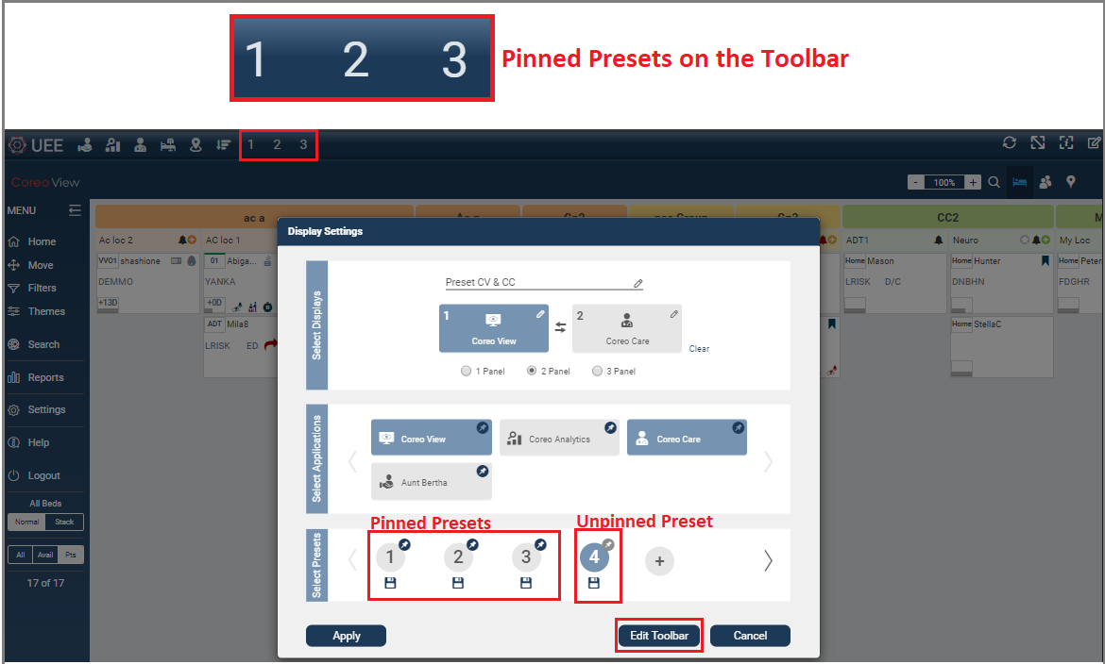

1. Presets Pinned to the Toolbar

The presets that are already pinned to the toolbar have blue colored pin icons, and the presets that are not pinned to the toolbar have grey colored pin icons.

1. Click the **Edit Toolbar** button.
2. Select the saved 2-panel preset icon to pin it to the toolbar of the UEE screen. On selecting, the preset icon displays a blue color pin indicating that the preset is pinned to the toolbar.

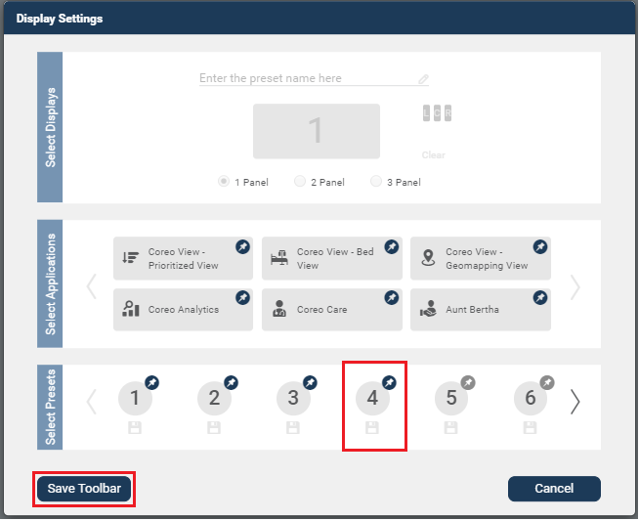

1. Pinning a 2-Panel Preset
2. Click the **Save** **Toolbar** button to save the changes that you made to the toolbar.

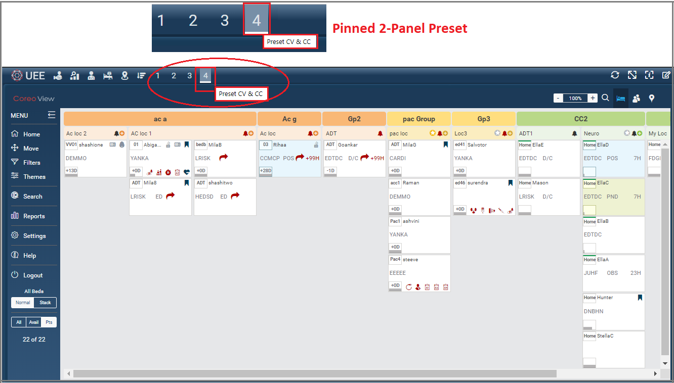

1. 2-Panel Preset Pinned to the Toolbar

The pinned preset displays on the toolbar. If the preset that you applied to the screen happens to be one of the pinned presets, then the preset icon highlights on the toolbar with a thin white bar below the preset number.

If you hover the mouse over the pinned preset icon, the preset name that you had defined in the **Display Settings** window shows as a tooltip, otherwise, UEE displays an auto-generated preset name in the format, **Preset ‘Number,’** *for example,* ***Preset******4****.*

## Configure a 3-Panel View

Follow these steps to configure a 3-Panel view in the **Display** **Settings** window and apply it on the UEE screen of your device:

1. Click the UEE application on the **Coreo Landing** screen to open the UEE screen.
2. Select the **Display** **settings** button or click anywhere in the blank panel frame to open the **Display** **Settings** window.

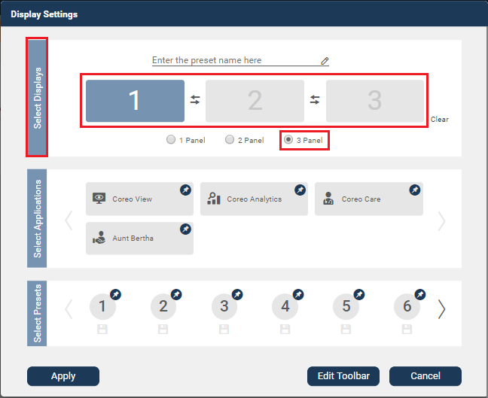

1. Display Settings Window—3 Panel Slot
2. In the **Select** **Displays** group, select the **3 Panel** radio button. A 3-panel slot displays.

You can use the **Clear** button to clear the panel slots to reassign the applications if the panel slots have preassigned applications.

1. Select the first panel, and in the **Select** **Applications** group, select the application to assign to the selected panel slot.
2. Similarly, select the second panel and third panel in the **Select** **Applications** group, and select the applications to assign to the selected panel slots.

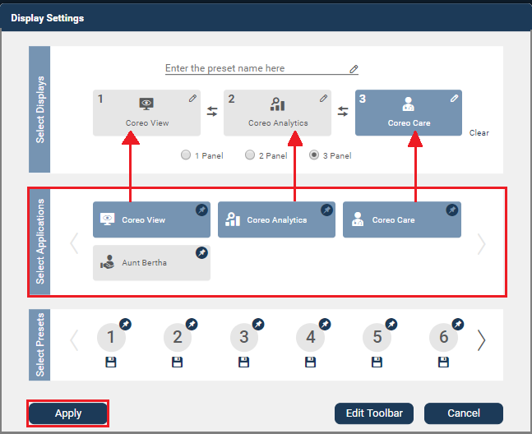

1. Display Settings Window—Assigning Applications to Panel Slots

If you choose to interchange the assigned applications between the panel slots, you can use the swap button .

*For example, if you have assigned the Coreo View application to panel 1 and Coreo Care application to panel 2 and if you click the Swap button, then the Coreo View application that was assigned to panel 1 is now assigned to panel 2 and Coreo Care application to panel 1. Similarly, you can swap the applications between panels 2 and 3.*

|  |  |
| --- | --- |
|  | UEE gives you the flexibility to select the panel slots in the order of your choice when assigning the applications to them; you can select panel 1, panel 2 and panel 3 in any order when assigning the applications. |

1. Click the **Apply** button to apply the 3-panel preset to the UEE screen on the monitor.

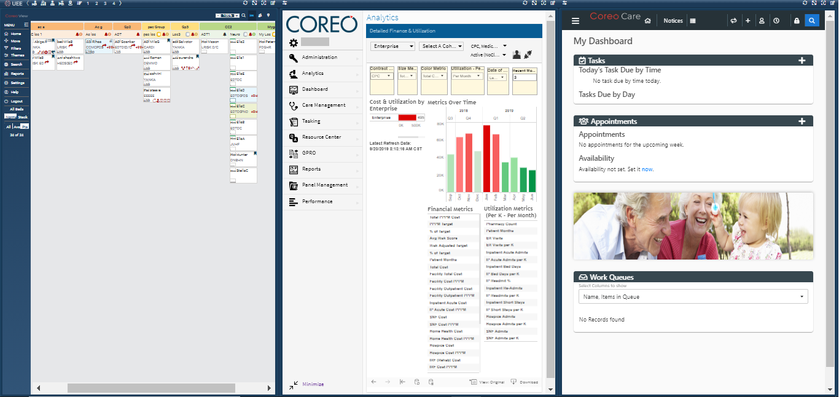

1. Device Screen in 3-Panel Mode

## Save a 3-Panel Configuration as a Preset

UEE gives the provision to save a 3-panel configuration as a preset. Saving presets help you to store the most frequently used configurations for later use.

Follow these steps to save a 3-panel configuration as a preset:

1. Select the **Display** **settings** button on the toolbar or click anywhere in the blank panel frame to open the **Display** **Settings** window.
2. Click the Add Preset button in the **Select Presets** group.

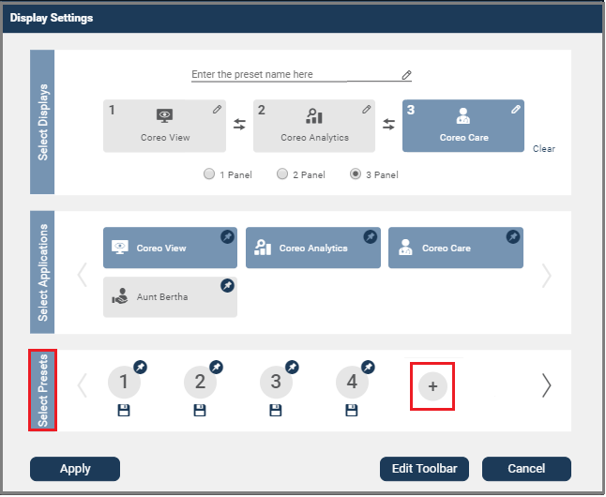

1. Display Settings Window—Adding a Preset

A new preset icon is created with the preset number auto-generated by UEE.

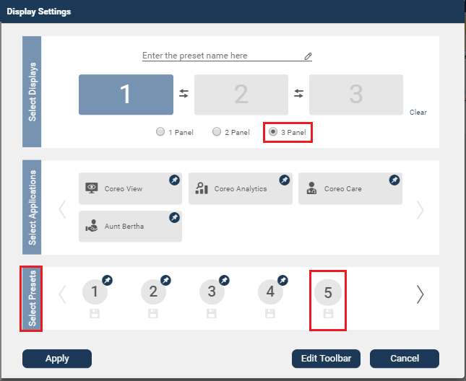

1. Display Settings Window—Newly Added Preset
2. Select the **3 Panel** radio button in the **Select Displays** group.
3. Select the first-panel slot, and from the **Select** **Applications** group, select the application to assign to the selected panel.

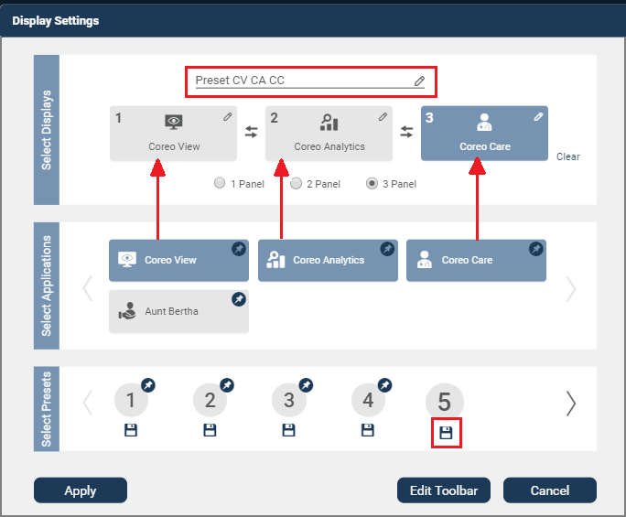

1. Select the second-panel slot, and from the **Select** **Applications** group, select the application to assign to the selected panel.
2. Similarly, select the third-panel slot and assign the application.
3. Enter the preset name in the **Enter the preset name here** box. This preset name displays as a tooltip to the pinned preset on the toolbar. You can also enter the preset name before assigning the applications to the panel slot.
4. Click the Save button below the preset icon in the **Select** **Presets** group to save the 3-panel configuration as a preset.

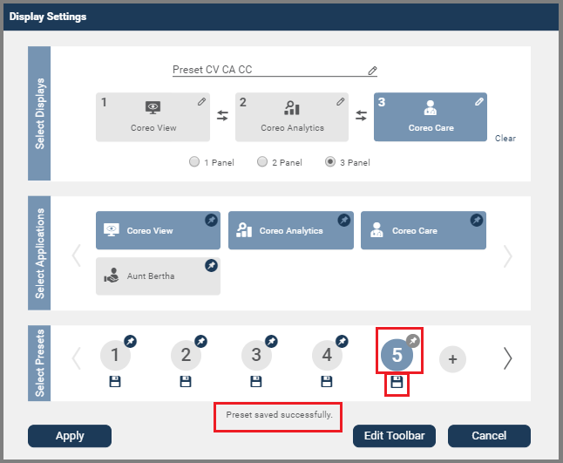

1. On saving the preset, a message, ‘**Preset saved successfully**’ displays indicating that the preset is saved successfully. A grey pin icon displays with the saved preset, and you can pin this preset to the toolbar.
2. Click the **Apply** button to apply the saved preset to the monitor screen immediately or click the **Cancel** button to exit the **Display** **Settings** window without applying the saved preset, but to use it when required.
3. Similarly, you can create more presets and save them for your next use.

## Pin a 3-Panel Preset to the Toolbar

Follow these steps to pin a 3-Panel preset to the toolbar:

1. Select the **Display** **settings** button on the toolbar or click anywhere in the blank panel frame to open the **Display** **Settings** window.
2. Click the **Edit Toolbar** button.
3. Select the 3-panel preset that you saved to pin it to the toolbar of the UEE screen. On selecting the preset icon, the grey colored pin changes to a blue color, indicating that the preset is pinned to the toolbar.

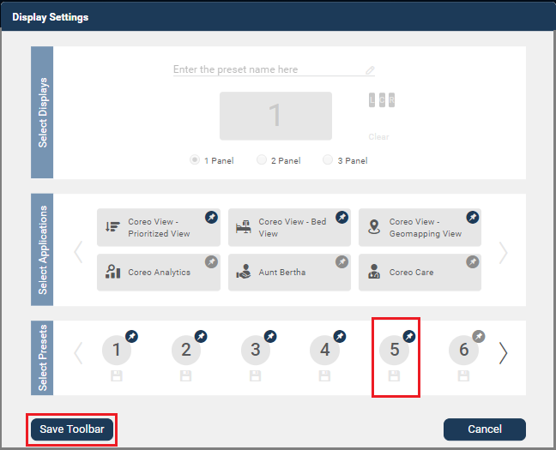

1. Pinning a 3-Panel Preset
2. Click the **Save** **Toolbar** button to save the changes that you made to the toolbar.

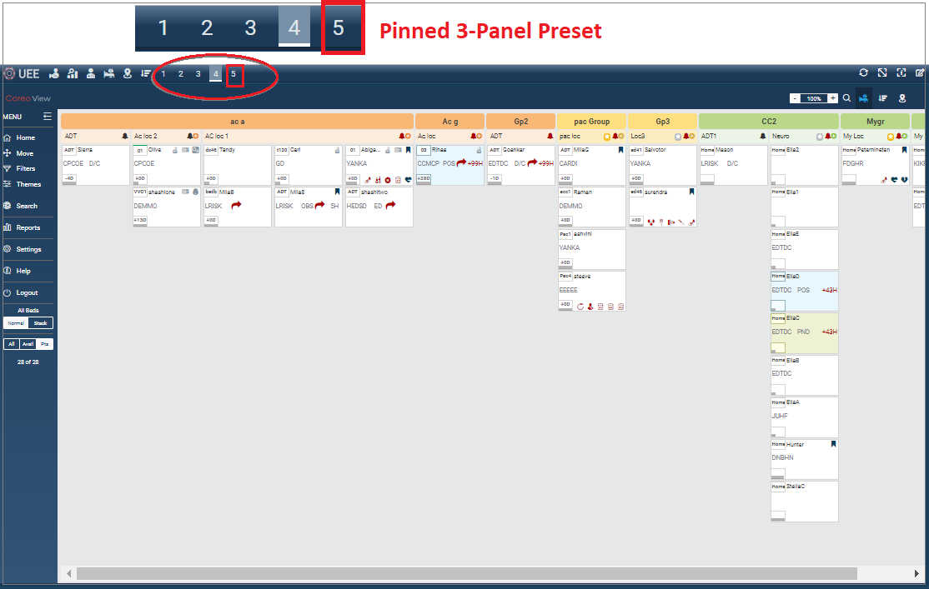

1. Preset Pinned to the Toolbar and Highlighted

The newly pinned preset displays on the toolbar.

## Screens for Optimal Display of Pinned Applications and Presets

You can view a maximum of 20 pinned applications and presets for a single panel display on standard screen monitors, beyond which you can use a chevron icon to navigate the screen and access the remaining pinned icons.

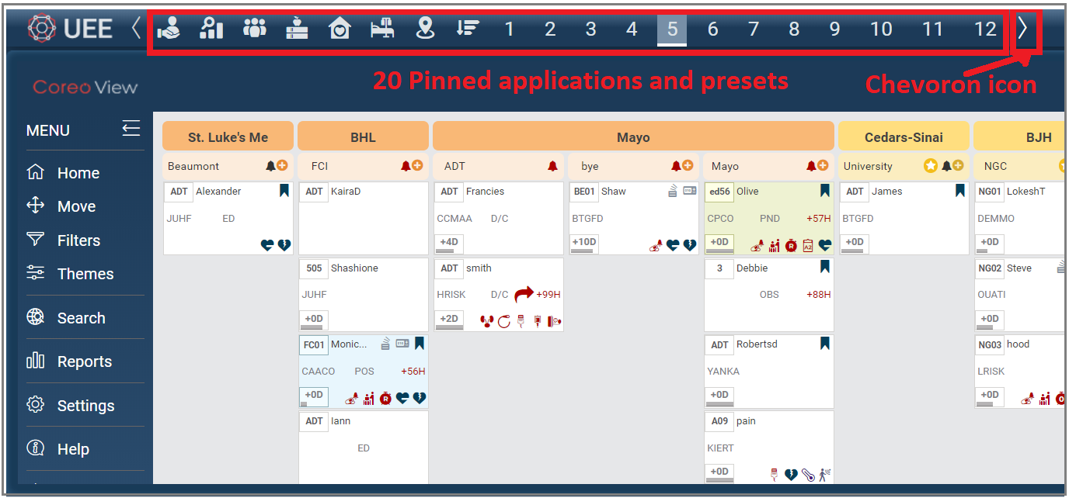

1. 20 Pinned Applications and Presets – Standard Screen- single panel mode

On widescreen monitors, for a single panel display, you can view a maximum of 33 pinned applications and presets, beyond which the user can use a chevron icon to navigate to the rest of the screen and access the remaining pinned icons.

For a 2-panel view and a 3-panel view, a maximum of 20 pinned applications and presets can be viewed both on standard screen monitors and on widescreen monitors.

The following table gives details about the number of pinned applications and presets that display for different panel modes for each screen type:

| Screen Type / Monitor | Panel Mode | Total No. of Pinned Applications and Presets on a single display |
| --- | --- | --- |
| Standard Screen | Single panel | 20 |
| Widescreen | Single panel | 33 |
| Standard Screen | 2-panel | 20 |
| Widescreen | 2-panel | 20 |
| Standard Screen | 3-panel | 20 |
| Widescreen | 3-panel | 20 |

1. Details about Pinned Applications and Pinned Presets

Editing an Existing Preset

UEE allows the user to modify an existing preset. Editing a presets includes the following:

* Change the applications that are assigned to the panel slots.
* Change from a 2-panel preset to a 3-panel preset and from a 3-panel to a 2-panel preset.
* Swap the applications between the panel slots to change the order in which the applications must display in a 2-panel or 3-panel view on the monitor.

The swap button in the **Display** **Settings** window functions, as shown in the following illustration:

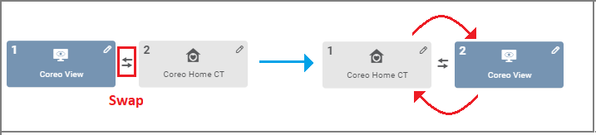

1. Swap Function in the Display Settings Button

You can use the swap button to interchange the applications between panels 1 and 2 slots and between panels 2 and 3 slots in the Display Settings window.

Follow these steps to make changes to an existing preset:

1. Select the **Display** **settings** button on the toolbar or click anywhere in the blank panel frame to open the **Display** **Settings** window.

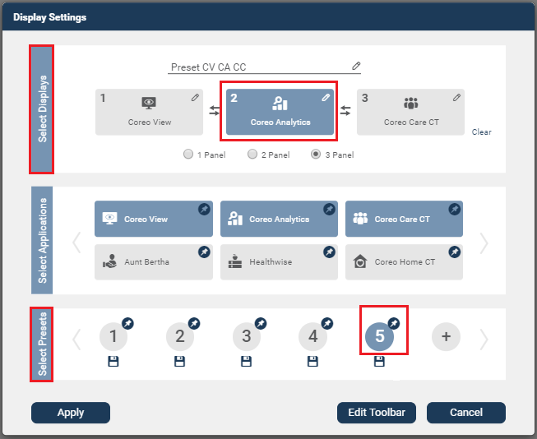

1. Edit an Existing Preset
2. Select an existing 2-panel or a 3-panel preset that you want to edit from the **Select** **Presets** group.
3. Select the panel slot for which you want to assign a new application from the **Select** **Displays** group.

You can either change the applications in all the preset slots (two preset slots and three preset slots) or just one slot.

|  |  |
| --- | --- |
|  | Use the Clear button to clear the applications of all the panel slots at a time. |

1. Use the swap button to only interchange the applications between the panel slots without assigning new applications.
2. From the **Select** **Applications** group, click the new application that you want to assign to the panel. The new application is assigned to the selected panel slot.
3. If required, you can change the preset name in the **Enter the preset name here** box.

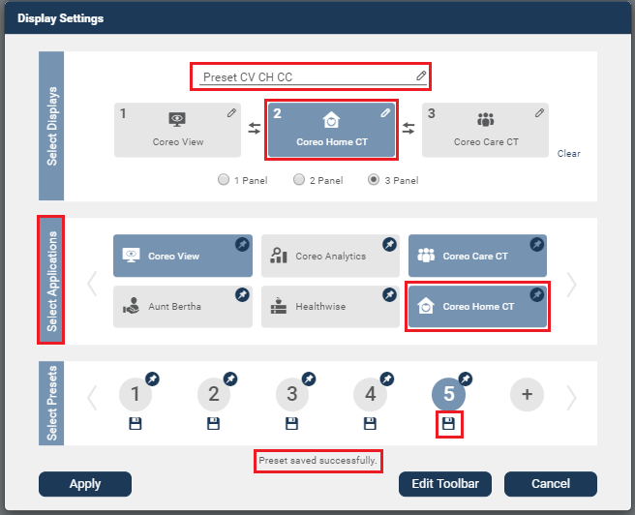

1. Click the save button below the preset icon that you want to edit. The changes that you made to the preset are saved. The message, ‘**Preset saved successfully’** displays on successfully saving the preset.
2. Click the **Apply** button to apply the saved preset to the monitor screen immediately or click the **Cancel** button to exit the **Display** **Settings** window without applying the saved preset, but to use it when required.

## Switch between Single Panel Mode and Multi-Panel Mode

UEE gives the provision to view the applications that you have access to through a single panel, 2-panel, or a 3-panel display.

Use the pinned applications on the toolbar to apply one of the applications of your choice in a single panel mode.

Use the pinned presets on the toolbar to apply a 2-panel view or a 3-panel view on your monitor screen.

You can choose to switch the view on the monitor screen from a single panel mode to a multi-panel mode (2-panel or 3-panel views). You can do this directly from the toolbar on the UEE screen, or the **Display** **Settings** window and then apply the changes on the UEE screen:

Follow these steps to change the UEE screen view from a single panel mode to a multi-panel mode from the toolbar of the UEE screen:

1. If you are not on the UEE screen already, click the UEE application on the Coreo Landing screen to open the UEE screen.

|  |  |
| --- | --- |
|  | When you open the UEE screen, the application or the preset that you last applied to the UEE screen in your previous login session displays. |

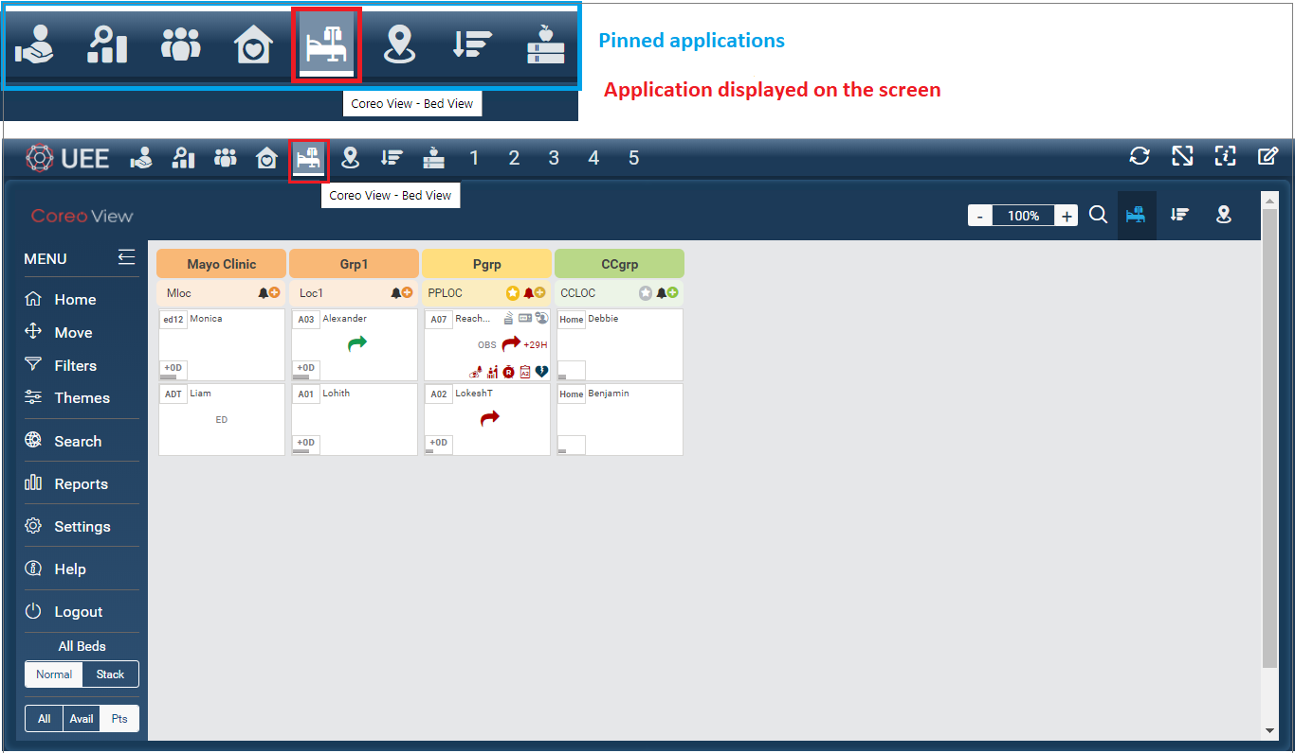

1. UEE Screen—Single Panel Mode—Coreo View-Bed View
2. Click preset **1** on the toolbar, which is a 2-panel preset, to apply to the UEE screen on your monitor.

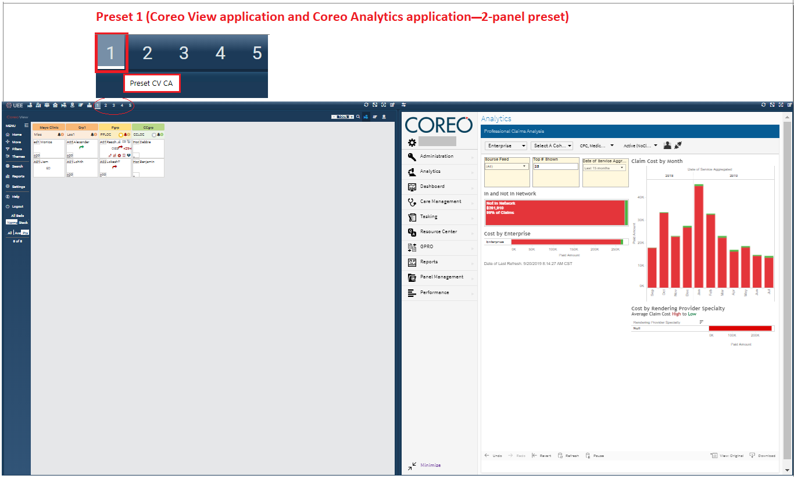

You can click the **Coreo View-Bed View** application icon to switch back to the single-panel view, or any pinned applications on the toolbar to revert to the single panel mode.

1. Similarly, click preset **2** on the toolbar, which is a 3-panel preset, to apply to the UEE screen on the monitor.

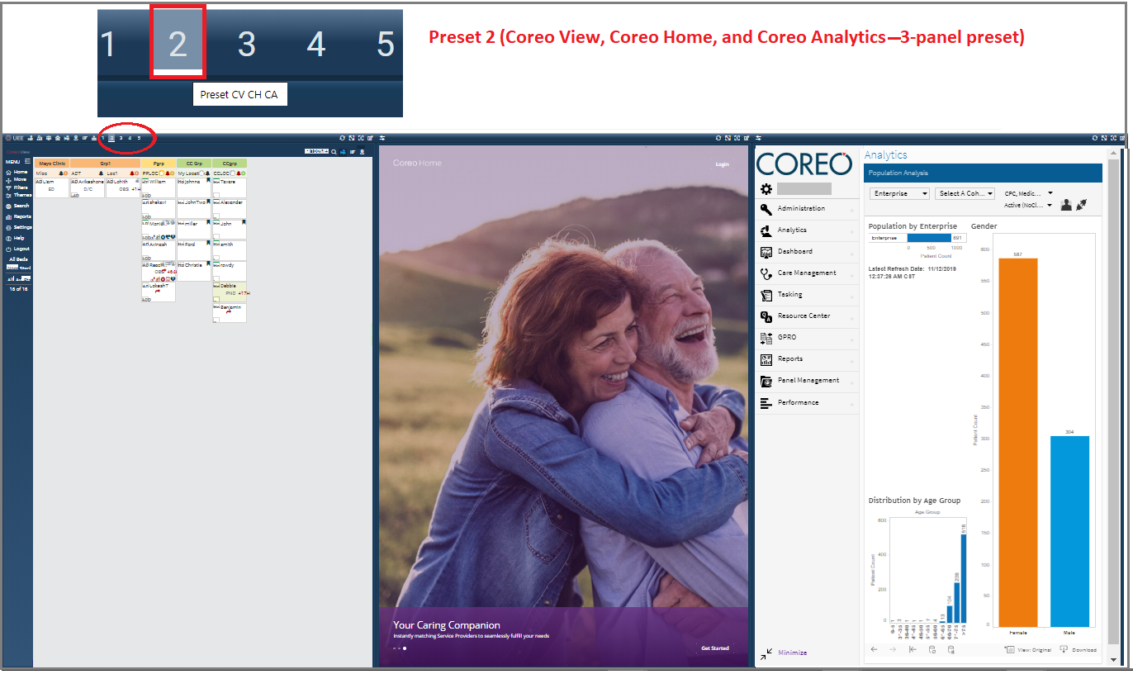

1. Click the **Swap** button on the toolbar that is located in the upper-left corner of the second panel to interchange the applications between the first panel and the second panel on the UEE screen of your monitor.

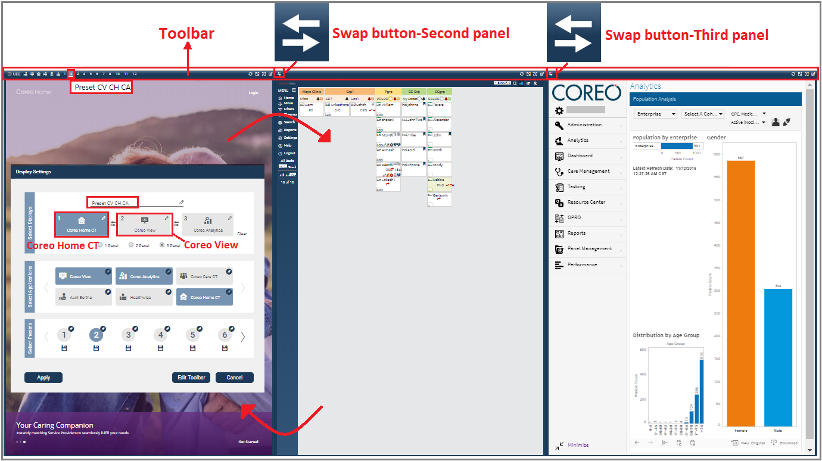

Similarly, you can use the **Swap** button of the third panel to interchange the applications between the second panel and the third panel.

|  |  |
| --- | --- |
|  | When you swap the applications of a saved preset on the UEE screen, UEE saves the changes in the Display Settings window as well. |

You can click any pinned applications, or any pinned presets on the toolbar to apply it to UEE screen, thereby you can switch between different applications within a single-panel view, or switch from a single-panel view to 2-panel view, and from a single-panel view to a 3-panel view.

Refer to the below table to view the various combinations in which you switch between panels:

| Panel Mode | **Switch** | Panel Mode |
| --- | --- | --- |
| Single panel view (Using pinned application)  *Example:*  *Coreo Analytics* | Single panel view (Using pinned application)  *Coreo Care* |
| Single panel view  *Example:*  *Coreo Analytics* | 2-panel view (Using pinned preset)  *Preset: Coreo View and Coreo Care* |
| Single panel view  *Example:*  *Coreo View – Prioritized View* | 3-panel view (Using pinned preset)  *Preset: Coreo View, Coreo Home, and Coreo Care* |
| 2-panel view  *For example, Preset: Coreo View and Coreo Analytics* | 2-panel view  *Preset: Coreo Care and Coreo Healthwise* |
| 2-panel view  *Preset: Coreo Home and Coreo Healthwise* | 3-panel view  *Preset: Coreo Analytics, Coreo Home, and Coreo Care* |
| 3-panel view  *Preset: Coreo Healthwise, Coreo Home, and Coreo Care* | 3-panel view  *Preset: Coreo View, Coreo Analytics, and Coreo Care* |

# Viewing Synchronized Patient Records

The view synchronization feature helps to establish consistency when viewing a patient record in different applications.

Synchronization allows harmonizing the patient record of one application with the same patient record of another application when viewing the applications in two or three different panels on your monitor screen.

For example, synching helps you to access the same patient record in the Coreo View application and Coreo Analytics application, simultaneously.

Similarly, you can view the same patient record in the Coreo View application and Coreo Care application, simultaneously.

Synchronize Patient Records Across Applications

In UEE, you can sync one patient record at a time in a unidirectional manner. That is, you can sync a patient record only from the Coreo View application with the same patient record in Coreo Analytics, and not vice versa. You cannot sync a patient record from Coreo Analytics with the patient record in Coreo View.

Similarly, you can only sync a patient record only from the Coreo View application with the same patient record in Coreo Care, and not vice versa.

Follow these steps to synchronize the patient record between Coreo View and Coreo Analytics:

There are four locations in the Coreo View application from which you can synchronize the patient record:

* On the **Bed View** layout
* On the **Prioritized View** layout
* On the **Global Map View** layout
* Through the global **Search** menu

create a preset or apply an existing preset with Coreo View application assigned to a panel and Coreo Analytics to another.

1. Glossary

**Configuration:** An arrangement in which the user can assign individual applications to different panels; The arrangement depends on the name of the application (such as Coreo View and Coreo Analytics), the number of panels (2-panels or 3-panels), and the order in which you assign them in the Display Settings window.

**Coreo UEE:** A Coreo ecosystem application that helps the users to view those applications in a single panel/monitor or in two panels/monitors or three panels/monitors that are accessible through the Navvis-Okta single sign-on account.

**Multi-panel mode:** The monitor screen displaying two different applications in two panels or three different applications in three panels, even with the flexibility of leaving one or two blank panels

**Panel:** A standard screen monitor or a widescreen monitor

**Single-panel mode:** The monitor screen displaying the application in one panel

**User:** The person who uses the Coreo UEE application

……………………..

1. Index

[Depending on the size or complexity of the final document, insert an index to assist the user in locating specific information. Index entries correspond to tags or categories, and are useful in navigating long books.]

[Index term – *page number*]

[Index term – *page number*]

[Index term – *page number*]

[Index term – *page number*]

[Index term – *page number*]